Kenya's Coordinated Fiscal and Monetary Policy Responses to the COVID-19 Pandemic
University of the People
ECON 1580-01 Applied Economics: Theory and Practice
Instructor: Dr Ramanpreet Kaur
December 24, 2025

Kenya's Coordinated Fiscal and Monetary Policy Responses to the COVID-19 Pandemic

Introduction
The onset of the COVID-19 pandemic in early 2020 triggered an unprecedented global health and economic crisis, prompting governments worldwide to deploy a mix of fiscal and monetary policy interventions to cushion economies from the ensuing shock. Kenya, like many other nations, faced considerable challenges, including declining economic growth, rising unemployment, and disrupted supply chains. In response, Kenyan authorities implemented a suite of coordinated fiscal and monetary policies aimed at mitigating the adverse effects of the pandemic, stabilising the economy, and supporting vulnerable households and businesses. This essay analyses Kenya’s fiscal and monetary policy measures during the pandemic, referencing key data and insights from the Institute of Economic Affairs (2022), Cytonn (2020), and Grant Thornton (2020), and evaluates their combined impact on inflation and economic stability. Understanding the effectiveness of these interventions provides valuable lessons for future crisis management and economic resilience.

Fiscal policy measures in Kenya
Kenya’s fiscal response to the COVID-19 pandemic was characterised by a range of tax reliefs, direct stimulus payments, social protection initiatives, and increased government expenditure. The government’s primary aim was to cushion citizens and businesses against the demand shock and loss of income brought about by pandemic containment measures. As detailed in Table 6 from the Institute of Economic Affairs (2022), several tax measures were enacted, including a reduction in corporate income tax from 30% to 25%, a drop in turnover tax for micro, small, and medium enterprises (MSMEs) from 3% to 1%, and a reduction in Value Added Tax (VAT) from 16% to 14%. Additionally, a 100% Pay-As-You-Earn (PAYE) tax relief was introduced for individuals earning below Ksh 24,000 per month, effectively increasing disposable income for low-income earners and stimulating consumption. These tax reliefs were estimated to result in significant revenue losses for the government, as illustrated by the differences in revenue collection before and after their implementation in Table 1, but were essential for immediate economic support.
Table 1
Kenya’s tax relief measures during the COVID-19 pandemic
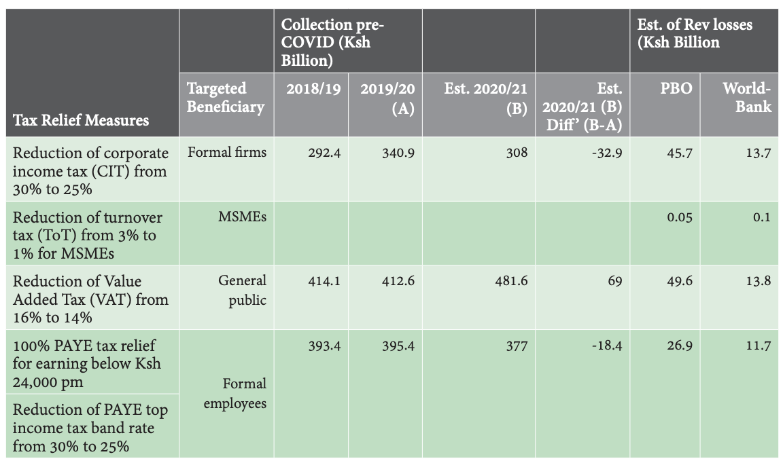
Beyond tax relief, the government channelled resources into social protection and expenditure measures. Notably, Ksh 10 billion was allocated for cash transfers to the elderly, orphans, and other vulnerable groups, and Ksh 1 billion was directed towards the recruitment of additional health workers. The government also mandated the clearance of pending bills amounting to Ksh 13.8 billion and expedited VAT refund claims of Ksh 10 billion to improve liquidity for businesses (Institute of Economic Affairs, 2022). Such measures were designed to inject liquidity into the economy, support employment, and preserve business continuity during the crisis.
While Kenya did not have a formal unemployment benefit system comparable to developed countries, the combination of tax reliefs and targeted stimulus payments functioned as temporary income support, particularly for formal sector workers and low-income households. Grant Thornton (2020) highlighted that these interventions were especially beneficial for casual workers and MSMEs, who faced acute cash flow challenges due to reduced business activities. The government’s actions provided a lifeline to the most affected segments of society, and the focus on verified VAT refunds and expanded eligibility for relief measures helped to address immediate liquidity constraints.

Monetary policy actions by the Central Bank of Kenya
Complementing fiscal interventions, the Central Bank of Kenya (CBK) implemented a series of monetary policy actions aimed at enhancing liquidity and lowering the cost of borrowing. According to Cytonn (2020), the CBK reduced the Central Bank Rate (CBR) by 100 basis points, from 8.25% to 7.25%, with the intention of encouraging lending and investment in an environment of heightened uncertainty. Additionally, the Cash Reserve Ratio (CRR) was lowered from 5.25% to 4.25%, effectively freeing up liquidity within the banking sector to support borrowers and maintain credit flow. Cytonn (2020) noted that these measures were crucial in providing additional liquidity to commercial banks, allowing them to extend credit to businesses and individuals facing financial strain due to the pandemic. The release of Ksh 7.3 billion to the National Treasury, sourced from previous demonetisation efforts, further bolstered fiscal resources and supported government spending initiatives. By lowering interest rates and reserve requirements, the CBK aimed to stabilise financial markets, prevent excessive tightening of credit conditions, and safeguard economic activity.

Combined impact on inflation and economic stability
The coordinated deployment of fiscal and monetary policies had a discernible impact on inflation and economic stability in Kenya. Despite the injection of liquidity and increased public spending, inflation remained within the Central Bank’s target range of 2.5% to 7.5%, with March 2020 inflation recorded at 6.1%, primarily driven by food price increases. Cytonn (2020) observed that inflationary pressures were largely attributable to supply-side disruptions rather than demand-side factors, as global lockdowns and supply chain interruptions heightened cost-push inflation. On the economic stability front, the fiscal and monetary interventions provided much-needed support to households and businesses, helping to avert deeper contractions in economic output. The Institute of Economic Affairs (2022) reported that Kenya’s GDP growth projections were revised downward in response to the pandemic, but the combined policy measures helped to cushion the economy and facilitate a gradual recovery. The targeted nature of tax reliefs and liquidity support ensured that the most vulnerable sectors received assistance while maintaining overall macroeconomic stability.
However, the expansionary policies also placed pressure on the government’s fiscal deficit and revenue collection targets, raising concerns about long-term sustainability. The temporary nature of some tax reliefs, and their subsequent reversal, reflected the government’s need to balance immediate economic support with prudent fiscal management. Ultimately, the coordinated policy response succeeded in stabilising inflation and supporting economic activity, but highlighted the importance of budgetary space and institutional capacity in managing future crises.

Conclusion
Kenya’s coordinated fiscal and monetary policy response to the COVID-19 pandemic exemplified a pragmatic approach to economic crisis management, balancing immediate relief with longer-term stability. Fiscal measures, including tax reductions, stimulus payments, and social protection initiatives, provided direct support to households and businesses, while monetary policy actions by the Central Bank ensured adequate liquidity and maintained market confidence. The combined impact of these interventions was to stabilise inflation, support economic recovery, and protect vulnerable groups. Nonetheless, the experience underscored the significance of fiscal discipline and the need for well-designed social safety nets. As Kenya and other nations prepare for future shocks, the lessons drawn from the COVID-19 response will be invaluable in shaping resilient and responsive economic policies.

References
Cytonn. (2020, April 20). COVID-19 pandemic economic containment policies. https://cytonn.com/topicals/covid-19-pandemic-economic
Grant Thorton. (2020, March 26). Relief measures – Kenya’s response to COVID-19. Grant Thornton Kenya. https://www.grantthornton.co.ke/globalassets/1.-member-firms/kenya/insights/pdf/grant-thornton-alert---tax---relief-measures---kenyas-response-to-covid-19.pdf
Institute of Economic Affairs. (2022). Shaping Macro Economy in Response to COVID-19 in Kenya: A Responsible Economic Stimulus and a Stable Financial Sector. https://idl-bnc-idrc.dspacedirect.org/server/api/core/bitstreams/d7799950-f8fc-4873-89a0-524949213159/content

